
ASIA PACIFIC UNIVERSITY OF TECHNOLOGY & INNOVATION
Individual Assignment
Module code | CT046-3-M
Module name | Applied Machine Learning
Intake code | CSSE___CT046-3-M-AML-L-1___2026-01-26
Hand-out date | 25 May 2026
Hand-in date | 24 July 2026
Weightage | 100%
Student name | Tanjim Noor
Student ID | TP166089

Declaration
I declare that this report is my own work except where the work of others is clearly acknowledged and cited. The submitted analysis is based on the stated dataset and the accompanying source code and notebooks. I have not presented this report, in whole or in part, for another academic award.
Generative-AI assistance was used for research-workflow support, code and report review, language editing, and document assembly. All literature claims, references, notebook outputs, numerical results, interpretations, and final wording were checked against the cited sources and the saved assignment evidence. Responsibility for the submitted work remains with the student.

Student name | Tanjim Noor
Student ID | TP166089

Predicting Semester GPA Change Using Student Context and Generative AI Usage: A Leakage-Controlled Machine Learning Study
────────────────────────
CT046-3-M: Applied Machine Learning
Individual Assignment
Submitted by
Tanjim Noor
TP166089
Asia Pacific University of Technology & Innovation
Submission date: 31 July 2026

Abstract
Generative-AI tools are used in higher education, but evidence about their relationship with academic performance remains mixed and context-dependent. This study investigated whether recorded AI-use variables improved out-of-sample prediction of semester GPA change beyond previous GPA and general study context, and which regression model provided the strongest validated performance. The Kaggle Impact of Ai on Students dataset contained 50,000 records and 16 source columns. Every field was audited for completeness, validity and distribution; no valid observations were changed. GPA change was defined as post-semester minus pre-semester GPA. Student_ID, post-semester GPA and two other post-outcome fields were excluded to prevent meaningless identification and outcome leakage. Numeric and categorical variables were processed through fold-fitted imputation, standardisation and one-hot encoding. A mean baseline, Linear Regression, Ridge Regression, Random Forest and Histogram Gradient Boosting (HGB) were compared using an 80/20 development-test split and shuffled five-fold cross-validation; HGB was subsequently tuned within the development data. The combined context-and-AI model achieved test R² = 0.4170, compared with 0.2382 for context only and 0.1703 for AI variables only. Untuned HGB produced the strongest model-comparison CV RMSE of 0.1443, while tuning reduced the best CV RMSE to 0.1441. On the reserved test set, tuned HGB achieved MAE 0.1112, RMSE 0.1414 and R² = 0.4185; 84.34% of predictions were within 0.20 GPA points. Traditional study hours, primary AI use case and weekly GenAI hours were the three largest permutation importances. These findings indicate that AI-related fields supplied additional predictive information when combined with student context and that nonlinear ensembles represented the recorded relationships better than linear models. However, undocumented dataset provenance and much higher error for GPA decreases prohibit causal or individual-decision conclusions.

Table of Contents
1 Introduction, Aim and Objectives 1
1.1 Problem context 1
1.2 Dataset and analytical problem 1
1.3 Research question 2
1.4 Aim 2
1.5 Objectives 2
1.6 Scope and contribution 3
2 Related Works 4
2.1 Review method 4
2.2 AI in higher education 5
2.3 Mixed evidence on academic outcomes 5
2.4 AI literacy and prompt skill 6
2.5 Predicting academic performance 7
2.6 Methodological and software foundations 8
2.7 Comparative synthesis and research gap 8
3 Methods 10
3.1 Research design 10
3.2 Data and feature groups 10
3.3 Experimental procedure 10
4 Dataset Preparation 13
4.1 Data understanding, audit and target construction 13
4.2 Preparation and leakage control 16
5 Model Implementation 18
5.1 Common pipeline 18
5.2 Candidate regressors 18
5.3 Feature-set ablation 19
5.4 Hyperparameter optimisation 19
5.5 Final fitting and interpretation outputs 20
6 Model Validation 21
6.1 Cross-validation and model selection 21
6.2 Test confirmation 21
6.3 Residual behaviour 22
6.4 Direction-specific error and bias risk 23
7 Analysis and Recommendations 24
7.1 Answer to the research question 24
7.2 Why nonlinear models performed better 24
7.3 Predictive importance and anomalies 25
7.4 Relationship to prior evidence 26
7.5 Recommendations 27
8 Conclusion 29
References 31
Acknowledgements 34

List of Figures
Figure 1. Data-quality results and original field-type composition. Zero counts for missing cells, duplicate rows, duplicate identifiers and invalid-range rows document why no corrective cleaning was applied. 13
Figure 2. Distributions of all original numeric and ordinal measures except the unique student identifier. 14
Figure 3. Frequency distributions for every categorical and Boolean source field. 14
Figure 4. Numeric correlation matrix and sampled relationship between previous GPA and GPA change. Post-semester outcomes are excluded from the predictor-focused matrix. 15
Figure 5. Counts and continuous distributions of GPA decreases, unchanged values and increases. The continuous target was retained without balancing. 15
Figure 6. Distribution of GPA change and descriptive relationships with previous GPA, prompt-engineering skill and weekly generative-AI hours. Error bars show 95% confidence intervals for group means. 16
Figure 7. Reserved-test RMSE by model and actual versus predicted GPA change for the selected tuned HGB model. The dashed diagonal represents perfect predictions. 22
Figure 8. Residuals against predicted GPA change and the residual distribution for tuned HGB. 22
Figure 9. Test MAE, RMSE and residual distributions separated by observed GPA-change direction. The same tuned model and untouched test set are used for all groups. 23
Figure 10. Test-set permutation importance for the selected tuned HGB model. Values show the mean deterioration in RMSE-based score after shuffling each source feature across five repetitions. 26

List of Tables
Table 1. Search coverage and screening outcome 4
Table 2. Core literature informing the study 8
Table 3. Experimental workflow and evidence role 12
Table 4. Dataset preparation decisions 16
Table 5. Candidate model specification 19
Table 6. HGB randomised-search space and selected configuration 20
Table 7. Five-fold cross-validation and reserved-test performance 21
Table 8. HGB feature-set comparison 24

1 Introduction, Aim and Objectives

1.1 Problem context
Generative artificial intelligence (GenAI) tools can produce explanations, drafts, summaries, code and feedback in response to natural-language prompts. Their rapid adoption has moved educational AI beyond systems selected by an institution: students can now decide whether, why and how intensively to use such tools. Earlier higher-education research already treated profiling and prediction as major AI applications (Zawacki-Richter et al., 2019), while more recent reviews identify prediction, assessment, tutoring and AI assistance across the field (Crompton & Burke, 2023). GenAI adds a difficult question to this landscape: do recorded differences in student use help explain or predict academic outcomes after conventional study context is considered?
Academic performance is often represented by grade point average (GPA). Raw post-semester GPA, however, is strongly related to previous GPA and can make a model appear successful without explaining academic change. In this report, GPA change refers to post-semester GPA minus pre-semester GPA. A positive number indicates improvement and a negative number indicates decline. Predicting this continuous difference retains both direction and magnitude, whereas a binary “improved/not improved” label would treat a change of 0.02 as equivalent to a change of 0.80.
The educational literature does not justify assuming that greater AI exposure will improve performance. Early reviews describe opportunities for tutoring, feedback and independent study but also identify inaccuracy, over-reliance and academic-integrity risks (Kasneci et al., 2023; Lo, 2023). Empirical results also depend on how use and performance are measured. It is therefore more defensible to ask whether AI-related fields contain predictive information than whether AI use caused GPA change.

1.2 Dataset and analytical problem
The analysis used the Kaggle Impact of Ai on Students dataset (Nagi sisiro, 2026). It contains 50,000 student records and 16 source columns covering major, year of study, previous GPA, conventional study hours, exam anxiety, weekly GenAI hours, use case, prompt skill, tool diversity, subscription, perceived dependency, institutional policy and post-semester outcomes. The file is large, mixed-type and suitable for comparing regression algorithms.
Its strengths are accompanied by substantial limitations. Kaggle does not document the institution, country, sampling design, collection instrument, observation period, ethics procedure or whether the records are observed or synthetic. The file also has no missing values or duplicate rows, despite the assignment's preference for an imperfect dataset. These conditions make it appropriate for demonstrating a rigorous machine-learning workflow, but not for estimating population prevalence or recommending that students change AI use to alter GPA.
The modelling problem was designed around leakage control. The derived GPA_Change target could be reconstructed if Post_Semester_GPA were retained as a predictor, so that field was excluded. Student_ID and the separate post-semester outcomes Skill_Retention_Score and Burnout_Risk_Level were also removed. Context variables and AI variables were compared separately and together, then five candidate regressors were evaluated using a common development-test split and five-fold cross-validation.

1.3 Research question
To what extent do AI-usage variables improve out-of-sample prediction of semester GPA change beyond previous GPA and general study context, and which regression model provides the strongest validated performance?
This wording sets two boundaries. “Out-of-sample” requires evaluation on rows not used to fit the corresponding model. “Prediction” limits the conclusion to associations within the supplied data.

1.4 Aim
The primary aim of this study was to build and critically evaluate leakage-controlled regression models for semester GPA change, with particular attention to the incremental predictive value of AI-usage variables.

1.5 Objectives
1. Examine the dataset's structure, integrity and GPA-change distribution without modifying the raw CSV or manufacturing data-quality problems.
2. Construct a defensible continuous GPA-change target and define separate context, AI-only and combined predictor groups.
3. Prevent identifier and post-outcome leakage through explicit feature exclusions and fold-local preprocessing.
4. Compare a mean baseline, Linear Regression, Ridge Regression, Random Forest and Histogram Gradient Boosting using consistent five-fold cross-validation.
5. Tune the strongest nonlinear model using development data only and confirm performance on a reserved 20% test set.
6. Interpret residuals, error tolerances and permutation importance against the literature, then make recommendations proportionate to the evidence.

1.6 Scope and contribution
The reported implementation is a single leakage-controlled regression workflow; supplementary deep-learning experiments are outside the report scope. Its technical contribution is a reproducible comparison of linear and nonlinear models, an explicit context-versus-AI feature ablation, and a validation hierarchy that uses cross-validation for selection and the test set for confirmation. Its critical contribution is equally important: it connects model results to a structured 15-source literature review while distinguishing predictive association from causal explanation. The following sections first synthesise the evidence base, then describe preparation, implementation and validation before analysing the findings and their practical limits.

2 Related Works

2.1 Review method
A structured multi-database search was conducted on 1 July 2026 to identify work relevant to generative-AI use, academic outcomes, AI literacy and student-performance prediction in higher education. Four query families combined: (1) generative AI or ChatGPT with academic performance; (2) AI-use behaviour, prompt engineering or AI literacy with student outcomes; (3) machine learning with GPA or academic-performance prediction; and (4) the exact Kaggle dataset title, filename and creator. Searches were run through ERIC and Crossref, supplemented by public Semantic Scholar result pages and publisher or DOI records. OpenAlex was attempted but its anonymous API required an API key or returned a rate-limit response; this was recorded as unavailable rather than interpreted as no evidence.
English publications from 2016 to 2026 were prioritised, with emphasis on work published after 2022 for generative AI. Eligible records included empirical higher-education studies, relevant reviews and methodological sources that could support model design or validation. Promotional material, unverifiable records, school-only studies, perception studies without a relevant outcome and duplicates were excluded. Records were deduplicated by DOI and normalised title. The review inspected 50 discovery records, verified 15 domain records by DOI, title, author and year, and retained them as the problem-focused core. Ten primary software or methodological publications were then verified to document tools, algorithms, tuning, validation and interpretation used in the implementation. The exact-dataset search located the Kaggle metadata but no inspectable peer-reviewed benchmark. The review is therefore reproducible and systematic in its search logic, but it is not presented as a complete PRISMA systematic review.
Table 1. Search coverage and screening outcome
Source | Search role | Records inspected | Core records retained
ERIC | All four query families | 17 | 10 before cross-database deduplication
Crossref | Broad discovery and targeted DOI verification | 20 broad results plus 15 DOI checks | 15 verified DOI records
Semantic Scholar | Supplementary public-result discovery | 13 | 3 before deduplication
OpenAlex | Planned discovery source | 0 | 0; access unavailable
Kaggle | Exact dataset and notebook search | Dataset metadata only | Dataset source; no comparative study

Counts overlap because studies appeared through several routes. Degraded API access was recorded rather than interpreted as negative evidence, and no Kaggle notebook was admitted without inspectable methods and results.
Quality appraisal covered design, sample, outcome, validation, leakage, self-reporting and causal overreach. It prevented pooled effects, classification accuracy and observational associations from being transferred uncritically to this regression.

2.2 AI in higher education
A considerable body of literature has examined artificial intelligence in higher education, although the focus has changed quickly. Zawacki-Richter et al. (2019) reviewed 146 studies published between 2007 and 2018 and grouped applications into profiling and prediction, assessment and evaluation, adaptive systems and personalisation, and intelligent tutoring. Their review also identified limited involvement of educators and limited attention to pedagogical and ethical questions. Crompton and Burke (2023) subsequently reviewed 138 studies from 2016 to 2022 and found prominent uses in prediction, assessment, AI assistance, tutoring and learning management. Together, these reviews establish student prediction as a longstanding application, but they largely precede widespread student access to generative AI.
The release of general-purpose conversational systems expanded the research problem from institutional analytics to student-controlled use. Lo's (2023) rapid review identified opportunities for tutoring, feedback and independent study alongside risks involving accuracy, academic integrity and over-reliance. Kasneci et al. (2023) similarly argued that large language models could support personalisation and feedback, but stressed reliability, bias, assessment and dependency. These sources justify examining AI use as a multidimensional context rather than assuming that use is uniformly beneficial or harmful. However, both reflect an early evidence base in which conceptual discussion was more developed than direct measurement of academic outcomes.

2.3 Mixed evidence on academic outcomes
Empirical findings do not support a simple relationship between “more AI” and better performance. Sun and Zhou's (2024) meta-analysis synthesised 65 independent studies from 28 articles and reported a medium positive pooled effect on academic achievement (g = 0.533). The effect varied across learning activities, content and samples, and the intervention designs differed from uncontrolled everyday use. The pooled result therefore supports the potential value of structured GenAI-assisted learning, not a universal benefit from usage hours.
By contrast, Abbas et al. (2024) developed a usage scale and analysed a three-wave survey of 494 university students in Pakistan. Greater reported use was associated with procrastination, memory loss and lower reported academic performance. Temporal separation strengthened the measurement design relative to a one-time survey, but self-reporting, contextual specificity and observational modelling still prevent a causal conclusion. Molerov et al. (2026) provide a further qualification using a German higher-education panel and verified chatbot-use information. Chatbot users completed reasoning tasks faster but not more accurately; frequent users passed more examinations but did not obtain better grades. The authors explicitly treated self-selection and partial cross-sectional comparison as limits.
The generalisability of this evidence is restricted by differing populations, tasks, exposure definitions and outcome measures. Positive findings are more common in structured learning interventions, whereas naturally occurring use may reflect workload, procrastination, prior skill or course demands. These differences are not contradictions that can be resolved by counting studies. They indicate that purpose, quality and context of use need to be represented alongside quantity.

2.4 AI literacy and prompt skill
AI literacy provides one framework for representing use quality. Ng et al. (2021) synthesised 30 articles and organised AI literacy around understanding, application, evaluation and creation, together with ethical awareness. This definition is broader than operational knowledge of a chatbot. Laupichler et al. (2022) reached a compatible conclusion after screening 902 records and including 30 studies in higher and adult education. They found that definitions, curricula and assessment instruments remained immature, limiting consistent measurement.
Prompt engineering is one component within this broader capability. Lee and Palmer's (2025) systematic review of 33 articles found that prompting can be learnt, but effective practice also requires domain knowledge, critical evaluation and iterative refinement. The participant base and success criteria in the literature were limited and heterogeneous. Consequently, a categorical Prompt_Engineering_Skill field can be a plausible predictor, but it should not be treated as a validated measure of comprehensive AI literacy. The present dataset also includes purpose of use, weekly hours, tool diversity, paid access, dependency and institutional policy, allowing a more contextual representation than hours alone.

2.5 Predicting academic performance
Student-performance prediction is methodologically diverse. Alyahyan and Düştegör (2020) argued that a useful study begins with a precise outcome and aligns feature selection, preprocessing, algorithm choice and evaluation with that outcome. Hellas et al. (2018), reviewing 357 studies, found growth in both predictors and algorithms but recurring weaknesses in reporting, validation and replication. These findings support the present focus on change in GPA rather than raw post-semester GPA, because the former asks a more specific question and reduces the dominance of previous attainment.
Primary studies show that behavioural and contextual data can support prediction, although published scores are not directly comparable. Waheed et al. (2020) used demographics, assessments and virtual-learning-environment clickstream data to predict performance and reported that deep neural models outperformed their alternatives. Yağcı (2022) compared six algorithms for final-examination classification among 1,854 university students and found Random Forest, neural network and support vector machine among the strongest, with approximately 70–75% accuracy. Both studies concern classification, different institutions and different inputs. Their accuracy cannot be compared with RMSE or R² for GPA-change regression.
Model labels also conceal consequential implementation choices. Probst et al. (2019) showed that Random Forest behaviour depends on parameters such as feature sampling, leaf size and tree count, supporting explicit configuration and tuning reports. More generally, preprocessing and model selection must be confined to development folds to prevent leakage. This study therefore compares all candidates on identical folds, reports variation across folds, tunes only the development data and reserves a test partition for confirmation.

2.6 Methodological and software foundations
The implementation also depends on literature beyond the educational problem domain. pandas supplied labelled data structures (McKinney, 2010), NumPy provided numerical arrays (Harris et al., 2020), and scikit-learn supplied the common estimator, pipeline and evaluation interfaces (Pedregosa et al., 2011). Matplotlib and seaborn supported reproducible exploratory and statistical graphics (Hunter, 2007; Waskom, 2021). These sources document tools used to produce the work; they are cited in Methods rather than treated as evidence about student outcomes.
Algorithm choice also had literature foundations. Ordinary and Ridge Regression supplied additive benchmarks, with Ridge adding coefficient shrinkage for correlated predictors (Hoerl & Kennard, 1970). Random Forest represented bootstrap-aggregated randomised trees (Breiman, 2001), while gradient boosting represented stage-wise fitting to residual error (Friedman, 2001). Random search provided a reproducible, budget-limited alternative to an exhaustive grid (Bergstra & Bengio, 2012). Cross-validation supported development-only model selection (Arlot & Celisse, 2010), and permutation importance was interpreted as fitted-model reliance rather than causal effect (Fisher et al., 2019). Method citations also appear where each choice is used.

2.7 Comparative synthesis and research gap
Table 2. Core literature informing the study
Source | Design and context | Main contribution | Limitation and relevance
Zawacki-Richter et al. (2019) | Systematic review; 146 higher-education studies | Established prediction as a major AI application | Predates GenAI; motivates educational and ethical scrutiny
Crompton and Burke (2023) | Systematic review; 138 studies | Mapped contemporary AI uses in higher education | Search ended as ChatGPT emerged
Lo (2023) | Rapid review; 50 publications | Synthesised early ChatGPT opportunities and risks | Early literature was often conceptual
Kasneci et al. (2023) | Multidisciplinary position paper | Connected learning support with reliability and dependency risks | No direct performance effect estimate
Abbas et al. (2024) | Scale study and three-wave survey; Pakistan | Linked reported use with adverse academic correlates | Self-report and observational design
Sun and Zhou (2024) | Meta-analysis; 65 studies, 1,909 participants | Reported a positive pooled achievement effect | Heterogeneous, mainly structured interventions
Molerov et al. (2026) | Panel/quasi-experimental assessment; Germany, N = 270 | Faster completion but not higher task accuracy or grades | Self-selection and limited causal identification
Ng et al. (2021) | Exploratory review; 30 articles | Defined AI literacy as understanding, use, evaluation, creation and ethics | Conceptual framework, not a validated measure
Laupichler et al. (2022) | Scoping review; 30 included studies | Found immature definitions and assessment of AI literacy | Broad, heterogeneous evidence
Lee and Palmer (2025) | Systematic review; 33 articles | Framed prompting as iterative and knowledge-dependent | Small participant base and subjective criteria
Alyahyan and Düştegör (2020) | Review and best-practice framework | Emphasised target definition and end-to-end design choices | Source studies used incompatible outcomes
Hellas et al. (2018) | Systematic review; 357 studies | Identified validation and reporting weaknesses | Broad educational contexts
Waheed et al. (2020) | VLE classification experiment | Demonstrated value of behavioural and prior-assessment data | Different target, setting and metric
Yağcı (2022) | Six-model classification comparison; N = 1,854 | Showed competitive nonlinear models in one course | Accuracy not comparable with regression error
Probst et al. (2019) | Methodological review | Explained ensemble parameter and tuning effects | Not education-specific
Breiman (2001); Friedman (2001) | Primary ensemble-method papers | Grounded Random Forest and gradient boosting choices | General methods, not educational evidence
Arlot and Celisse (2010); Bergstra and Bengio (2012) | Methodological studies | Supported cross-validation and random search | Procedures still depend on suitable splits and search spaces
Fisher et al. (2019) | Model-reliance methodology | Supported permutation-based interpretation | Importance remains model- and correlation-dependent

Note. AI = artificial intelligence; GenAI = generative artificial intelligence; VLE = virtual learning environment. The outcomes and metrics summarised in this table are methodologically informative but are not direct numerical benchmarks for GPA-change regression.
Table 2 shows a clear gap between the GenAI-outcomes literature and the student-prediction literature. The former asks whether or how AI relates to learning but often relies on self-report, interventions or broad achievement measures. The latter develops predictive models but usually omits detailed GenAI behaviours and frequently uses classification targets. No defensible analysis using the exact Kaggle dataset was located. It would therefore be misleading to manufacture a same-dataset benchmark.
The present work addresses a narrower gap: it tests whether AI-use variables add held-out predictive information beyond previous GPA and general study context, while comparing linear and nonlinear regressors under a common, leakage-controlled validation procedure. This does not resolve whether AI use improves learning. Its contribution is to separate incremental prediction from causal interpretation and to show how a contemporary but provenance-opaque dataset can be analysed without overstating its evidential value.

3 Methods

3.1 Research design
This study used a cross-sectional predictive modelling design. Its unit of analysis was one student record in the supplied tabular dataset, and its outcome was the change between pre-semester and post-semester grade point average (GPA). In this report, GPA change refers to:
GPA Change = Post-semester GPA − Pre-semester GPA
Positive values denote an increase and negative values denote a decrease. A regression design was selected because the target is continuous. This preserves the magnitude of change that would be lost by reducing the outcome to “improved” or “declined”. The design addresses prediction and comparison; it does not estimate an effect of AI use.

3.2 Data and feature groups
The source was the Impact of Ai on Students dataset downloaded from Kaggle (Nagi sisiro, 2026). It contained 50,000 records and 16 source columns. The target was derived after loading the data. Twelve predictors were divided into two conceptually distinct groups. The context group contained Pre_Semester_GPA, Major_Category, Year_of_Study, Traditional_Study_Hours and Anxiety_Level_During_Exams. The AI group contained Weekly_GenAI_Hours, Primary_Use_Case, Prompt_Engineering_Skill, Tool_Diversity, Paid_Subscription, Perceived_AI_Dependency and Institutional_Policy. Comparing context-only, AI-only and combined models made the research question directly testable.
Four fields were excluded from all predictors. Student_ID was an identifier without a defensible substantive meaning. Post_Semester_GPA was used to construct the target and would reveal its outcome. Skill_Retention_Score and Burnout_Risk_Level were separate post-semester outcomes. Their removal was a deliberate leakage control rather than optional feature selection.

3.3 Experimental procedure
The analysis was implemented in Python 3.13.11 with pandas 3.0.3, NumPy 2.4.6 and scikit-learn 1.9.0. These libraries respectively provided labelled tabular operations, numerical arrays and consistent machine-learning estimators (Harris et al., 2020; McKinney, 2010; Pedregosa et al., 2011). Matplotlib 3.10.9 and seaborn 0.13.2 generated the statistical graphics (Hunter, 2007; Waskom, 2021). A fixed random state of 42 was used. A single random 80/20 split produced 40,000 development records and a reserved test set of 10,000 records. All model selection was performed within the development data using shuffled five-fold cross-validation with the same folds for every model. Cross-validation estimates performance across repeated development partitions and supports model selection without fitting on the reserved test observations (Arlot & Celisse, 2010). This consistent protocol was important because student-performance prediction studies often differ in targets, data and evaluation choices, making disciplined within-study comparison more informative than isolated scores (Alyahyan & Düştegör, 2020; Hellas et al., 2018).
Preprocessing and estimation were joined in scikit-learn pipelines. Numeric features passed through median imputation and standardisation; categorical and Boolean features passed through most-frequent imputation and one-hot encoding with unknown categories ignored. Although the observed file had no missing values, these steps made the workflow robust to missing or unseen values. Crucially, transformer parameters were fitted within each training fold, not on the complete dataset.
The candidate set comprised a mean dummy baseline, ordinary least-squares Linear Regression, Ridge Regression, Random Forest and Histogram Gradient Boosting (HGB). Mean absolute error (MAE) reported typical absolute error in GPA points. Root mean squared error (RMSE) penalised larger errors more heavily and was the primary selection metric. The coefficient of determination (R²) described the proportion of test-set variation accounted for by the predictions relative to the mean baseline. Lower MAE and RMSE and higher R² indicate better performance.
HGB was selected for optimisation only after it achieved the lowest untuned cross-validated RMSE. RandomizedSearchCV evaluated ten parameter combinations over learning rate, leaf count, minimum leaf size, L2 regularisation and number of boosting iterations. Search, scoring and refitting remained inside the development data. Test outputs were treated as confirmatory: the same reserved partition supported the prespecified feature-set comparison, candidate-model confirmation, residual summaries and permutation importance. It did not alter the search space or trigger model refitting, but these multiple reporting uses mean that it was not a strict single-look test benchmark.
No ethics approval is claimed for the secondary analysis because the dataset was obtained as a public CC0 modelling file and contains only a unique numeric identifier without documented personal meaning. Nevertheless, the source provides no account of consent or ethical review. This absence is an evidence limitation and prevents treating public availability as proof of ethical provenance.
Table 3. Experimental workflow and evidence role
Stage | Data used | Purpose
Integrity checks and target construction | All raw records | Verify schema and define the continuous outcome
Development-test split | All eligible records | Reserve 20% for final confirmation
Five-fold comparison | Development data only | Select the strongest model family
Randomised tuning | Development folds only | Optimise the selected HGB family
Final evaluation | Reserved test set | Confirm generalisation and inspect errors
Permutation importance | Reserved test set | Describe model-specific predictive contribution

4 Dataset Preparation

4.1 Data understanding, audit and target construction
The raw CSV was loaded without modification. It contained 50,000 rows and 16 source columns: eight numeric or ordinal measures, six categorical fields, one Boolean field and one integer identifier. The fields covered academic background, study behaviour, generative-AI use, institutional policy, exam anxiety and post-semester outcomes (Nagi sisiro, 2026).
Every field was profiled for data type, non-null count, missing count, cardinality and, where applicable, numeric range. The audit found 50,000 unique student identifiers, no missing cells, no duplicated rows and no duplicated identifiers. Both GPA fields were within 0–4; weekly AI and traditional-study hours were within feasible weekly limits; and diversity, dependency, anxiety and retention measures stayed within their documented scale limits. Complete category-frequency tables exposed every observed level and no inconsistent spellings. Figure 1 summarises the quality checks and field types.
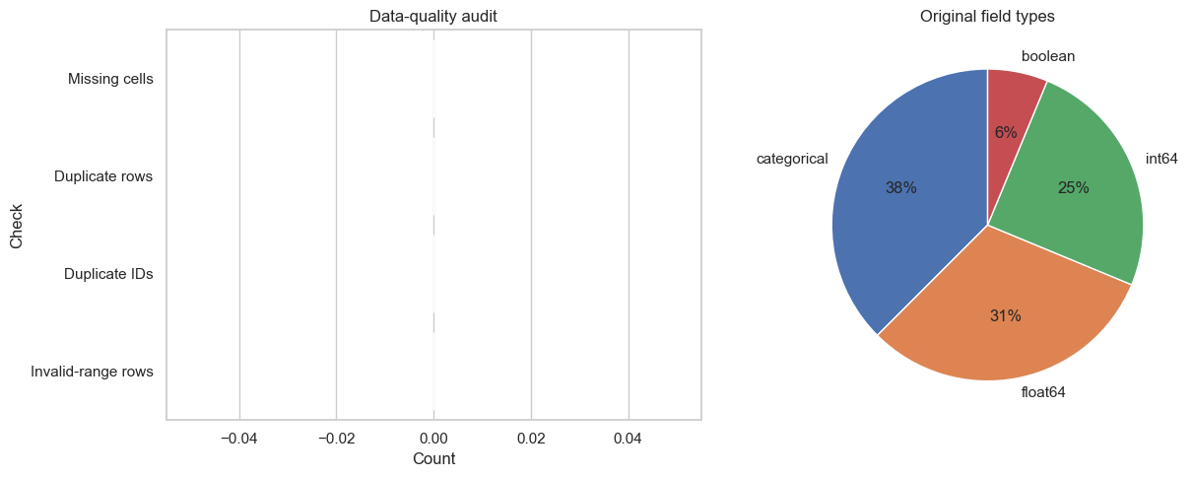
Figure 1. Data-quality results and original field-type composition. Zero counts for missing cells, duplicate rows, duplicate identifiers and invalid-range rows document why no corrective cleaning was applied.
Numeric exploration reported descriptive statistics, distributions and IQR outlier flags for every measured field (Figure 2). Flags prompted inspection, not automatic deletion. Figure 3 reports every categorical and Boolean frequency before encoding.
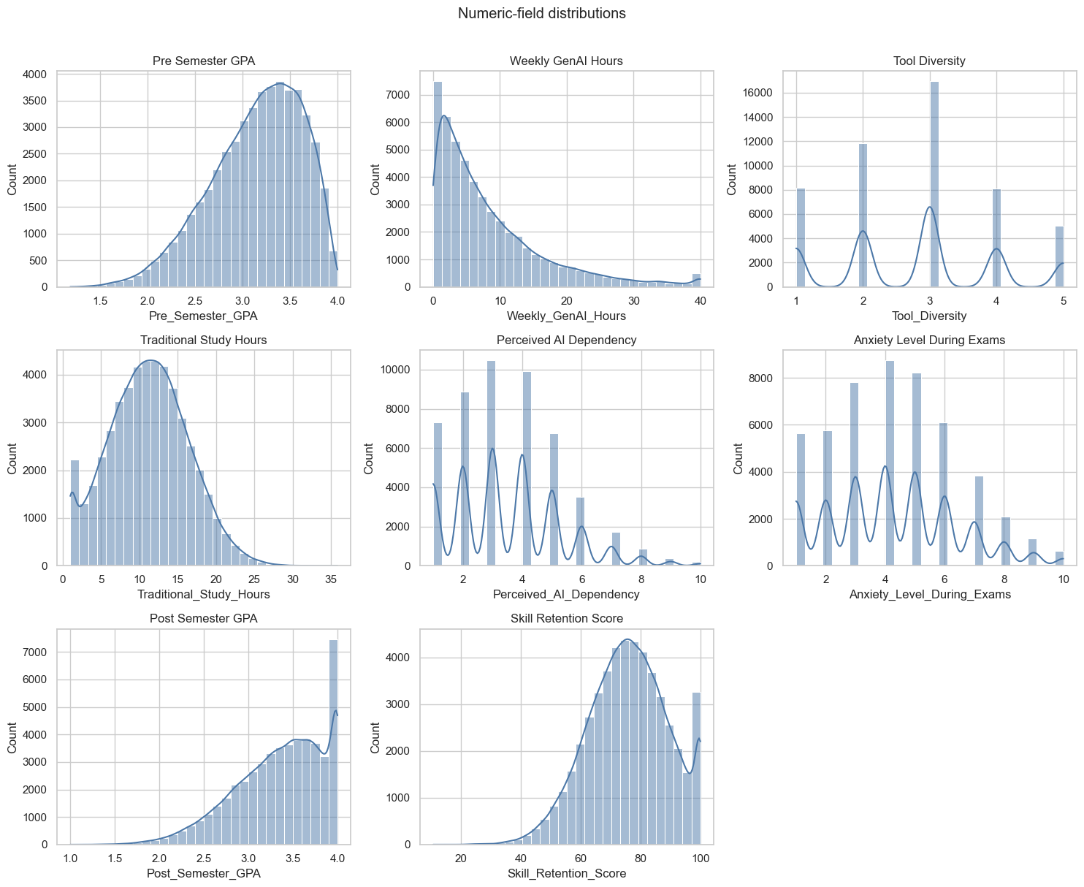
Figure 2. Distributions of all original numeric and ordinal measures except the unique student identifier.
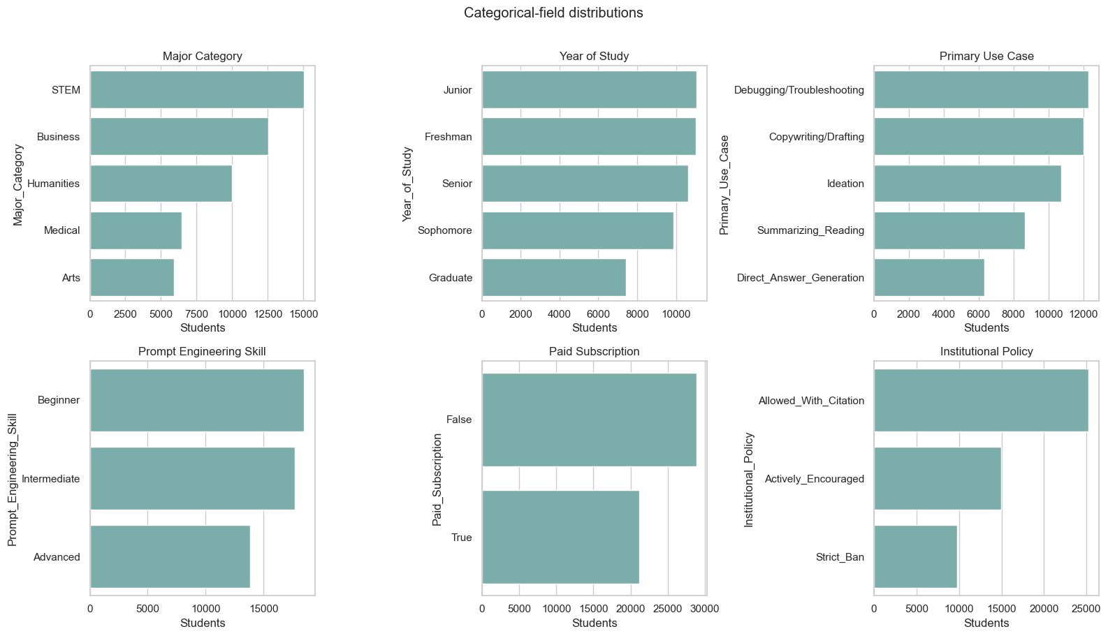
Figure 3. Frequency distributions for every categorical and Boolean source field.
GPA_Change was derived as post-semester minus pre-semester GPA, increasing the in-memory working table to 17 columns without changing the raw file. The target mean was 0.2032 GPA points, its standard deviation was 0.1872 and its median was 0.2040, with values from -0.924 to 1.008. Figure 4 presents numeric correlations and the bounded relationship between previous GPA and GPA change. These correlations support exploration of predictive structure but do not establish causation.
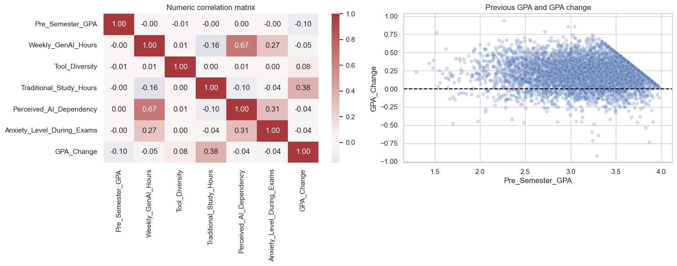
Figure 4. Numeric correlation matrix and sampled relationship between previous GPA and GPA change. Post-semester outcomes are excluded from the predictor-focused matrix.
There were 43,759 positive changes (87.52%), 6,192 negative changes (12.38%) and 49 unchanged records (0.10%). Figure 5 makes this asymmetry explicit. It is not conventional class imbalance because the model predicts a continuous quantity rather than an increase/decrease class. Resampling by sign would change the observed target distribution and regression estimand. All records were therefore retained, while direction-specific test errors were added to detect performance differences hidden by aggregate metrics.
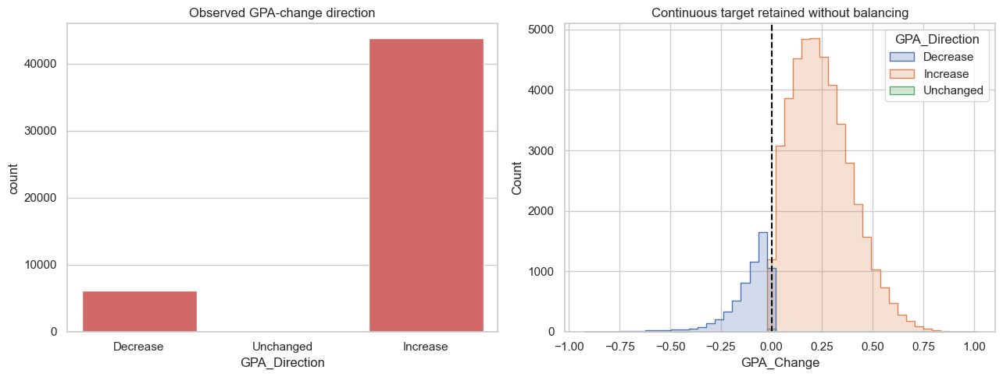
Figure 5. Counts and continuous distributions of GPA decreases, unchanged values and increases. The continuous target was retained without balancing.
Figure 6 shows an approximately unimodal target, a GPA-ceiling relationship, prompt-skill differences and non-monotonic AI-hours quartiles. These unadjusted patterns support nonlinear modelling but do not identify causal effects.
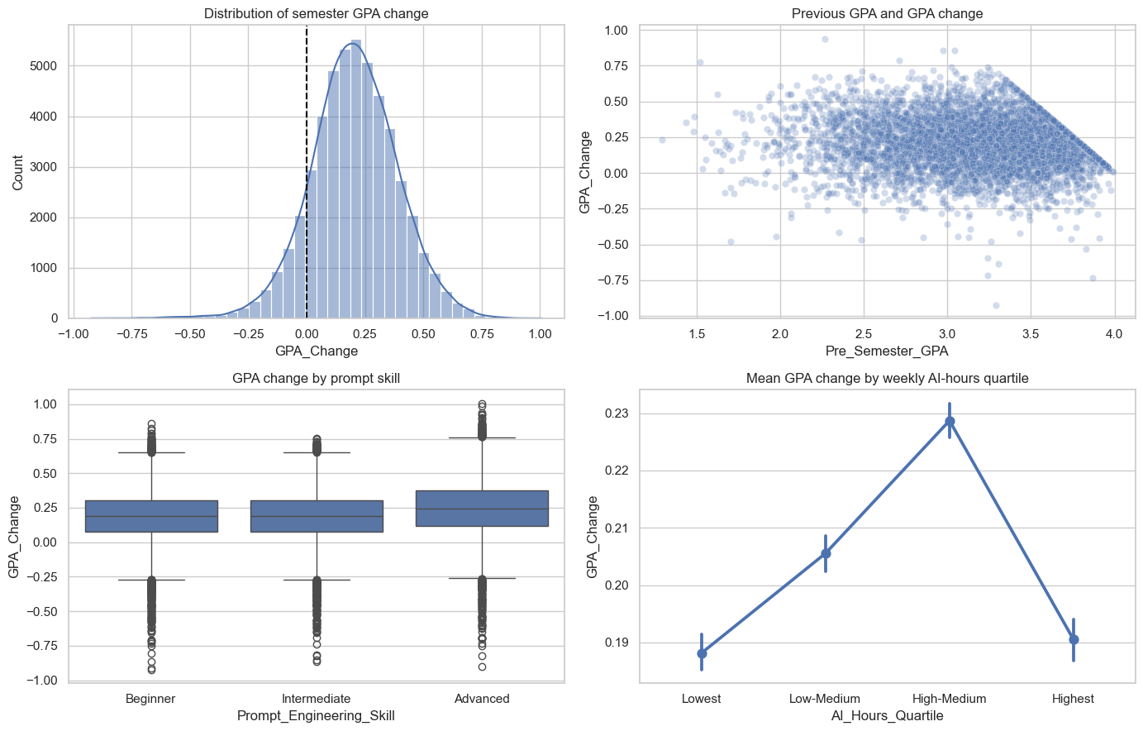
Figure 6. Distribution of GPA change and descriptive relationships with previous GPA, prompt-engineering skill and weekly generative-AI hours. Error bars show 95% confidence intervals for group means.

4.2 Preparation and leakage control
Table 4 records every preparation decision. Student_ID was excluded because record identity has no transferable meaning. Post_Semester_GPA was used only to construct the target; retaining it as a predictor would reveal the answer. Skill_Retention_Score and Burnout_Risk_Level were excluded as separate post-semester outcomes unavailable at the intended prediction point. AI_Hours_Quartile and GPA_Direction were diagnostic fields only; models retained continuous hours and continuous GPA change.
Table 4. Dataset preparation decisions
Action | Fields or rule | Rationale
Construct target | Post-GPA minus pre-GPA | Preserve magnitude and direction of academic change
Remove identifier | Student_ID | Avoid arbitrary record identity
Remove target source | Post_Semester_GPA | Prevent direct outcome leakage
Remove other outcomes | Skill_Retention_Score, Burnout_Risk_Level | Preserve a predictor-only feature set
Audit validity | Missingness, duplicates, ranges, categories, IQR flags | Demonstrate cleaning decisions from evidence
Encode categories | Fold-fitted one-hot encoding; ignore unknown levels | Represent nominal values without artificial ordering
Prepare numeric fields | Fold-fitted median imputation and standardisation | Provide robustness and linear-model comparability
Retain clean observations | No deletion, fabrication or forced transformation | Preserve valid supplied data
Retain target distribution | No balancing by GPA-change sign | Preserve the continuous regression estimand
Add direction diagnostic | GPA_Direction, evaluation only | Detect unequal errors hidden by overall averages

Encoders, imputers and scaling remained inside model pipelines, so every fold learned transformations from training data only. No imputation was activated, but the pipeline defines future missing-value handling without manufacturing present defects.
Complete cleaning was demonstrated through audits, validity rules and the decision log; it does not require changing valid data. Kaggle does not document collection, sampling, ethics or whether records are observed or synthetic. Perfect cleanliness is therefore a provenance warning, not proof of quality.

5 Model Implementation

5.1 Common pipeline
Every candidate used the same train-test indices, five cross-validation folds and preprocessing architecture. This controlled comparison isolates differences in the estimators rather than allowing each model to benefit from a different data treatment. Numeric columns were median-imputed and standardised. Categorical and Boolean columns were most-frequent-imputed and one-hot encoded. The dense encoded matrix was then supplied to the estimator. Because the preprocessor and estimator formed one Pipeline, fitting within a cross-validation fold could not learn category levels, medians, modes or scale parameters from its validation partition.
The mean baseline was essential even though it was not a learning model. It predicted the development-set mean GPA change for every record and established the minimum performance that a useful regression model should exceed. Its expected R² is around zero on unseen data; a negative value means that even the fixed mean would perform better.

5.2 Candidate regressors
Ordinary least-squares Linear Regression provided an interpretable additive benchmark. It assumes that the encoded predictors contribute through linear combinations and therefore cannot directly represent thresholds or interactions. Ridge Regression used the same functional form with an L2 penalty and alpha=1.0. It tests whether shrinking correlated or weak coefficients improves generalisation (Hoerl & Kennard, 1970).
Random Forest represented bagged nonlinear trees with random feature selection (Breiman, 2001). The implementation used 180 trees, a minimum of three samples per leaf and 80% of available features at each split (max_features=0.8). Setting n_jobs=1 within the estimator avoided nested model-level parallelism, while the cross-validation operation could run folds in parallel. A fixed random state made bootstrap sampling and feature selection reproducible. Tree ensembles were suitable because the exploratory patterns suggested possible thresholds and interactions, and comparable educational-data-mining studies have found tree-based methods competitive with linear and other classifiers (Yağcı, 2022). That prior classification result was methodological context, not a numerical benchmark for this regression.
Histogram Gradient Boosting built trees sequentially, with each iteration reducing residual error from the preceding ensemble. Histogram binning makes the method efficient for 50,000 rows; its stage-wise logic follows gradient boosting (Friedman, 2001). The untuned comparison used 180 boosting iterations, learning rate 0.07 and 31 maximum leaf nodes. Its capacity to learn non-additive structure was relevant to the non-monotonic AI-hours pattern and the ceiling-shaped relation between previous GPA and GPA change.
Table 5. Candidate model specification
Model | Key implementation settings | Analytical role
Mean baseline | strategy="mean" | Minimum predictive reference
Linear Regression | scikit-learn defaults | Unregularised additive benchmark
Ridge Regression | alpha=1.0 | Regularised additive benchmark
Random Forest | 180 trees; minimum leaf 3; 80% features; seed 42 | Bagged nonlinear ensemble
HGB | 180 iterations; rate 0.07; 31 leaves; seed 42 | Boosted nonlinear ensemble

5.3 Feature-set ablation
Before the broad model comparison, the same HGB procedure was applied to three feature sets. The context-only model used five academic and study-context variables. The AI-only model used seven AI behaviour, skill and institutional variables. The combined model used all 12. For this ablation, HGB used 150 iterations, learning rate 0.08 and 31 maximum leaf nodes. Holding the estimator and data partition constant meant that the difference between context-only and combined performance could be interpreted as incremental predictive information from the AI feature group within this dataset.
This is not the same as a treatment comparison. Some AI variables may encode unobserved differences in courses, students or institutional settings, and the dataset contains no random assignment or credible non-user control group. Accordingly, the ablation quantifies prediction, not an AI-induced GPA change.

5.4 Hyperparameter optimisation
HGB achieved the lowest mean cross-validated RMSE in the untuned comparison and was therefore the only family passed to optimisation. Restricting tuning to the development data preserved the test set for confirmation. A randomised search evaluated ten sampled combinations from the space in Table 6. RMSE was the search objective because it expresses error in GPA points while assigning greater cost to large mistakes. Random search was chosen because it can inspect more distinct values per influential hyperparameter than an equally sized grid when only some dimensions strongly affect performance (Bergstra & Bengio, 2012).
Table 6. HGB randomised-search space and selected configuration
Hyperparameter | Candidate values | Selected
Learning rate | 0.03, 0.05, 0.08, 0.10 | 0.05
Maximum leaf nodes | 15, 31, 63 | 15
Minimum samples per leaf | 10, 20, 40 | 10
L2 regularisation | 0.0, 0.1, 1.0 | 0.1
Maximum iterations | 120, 180, 240 | 180

The selected configuration combined a smaller learning rate with 180 iterations, fewer maximum leaves and modest L2 regularisation. This represents gradual learning with constrained tree complexity. Explicitly reporting such controls is important because ensemble performance depends on tuning choices, and broad algorithm labels conceal materially different model capacities (Probst et al., 2019).
The best search score was a five-fold RMSE of 0.1441, compared with 0.1443 for the strongest untuned HGB comparison. The improvement was therefore only 0.0002 GPA points at the displayed precision. The optimisation still demonstrated a valid tuning procedure, but its small gain indicates that the initial HGB settings were already close to the useful region of the tested space.

5.5 Final fitting and interpretation outputs
After search completion, the best pipeline was refitted on all 40,000 development rows. The same procedure was used to fit the untuned models so that all candidates could be evaluated on the reserved 10,000-row test set. Predictions from the tuned HGB were retained for residual analysis.
Permutation importance was calculated on the test data with RMSE scoring, five repetitions and random state 42. Each source feature was shuffled while the fitted pipeline remained fixed; the mean deterioration in score described how much the model relied on that feature. This method can capture contribution in a nonlinear pipeline but remains sensitive to correlated predictors and the specific fitted model. It was used for interpretation, not for asserting that a feature produced the outcome. Permutation-based importance measures model reliance rather than an independent or causal effect, and correlated predictors can share or mask reliance (Fisher et al., 2019).

6 Model Validation

6.1 Cross-validation and model selection
Table 7 reports the five-fold development results used for model selection. All four trained regressors clearly outperformed the mean baseline. Histogram Gradient Boosting (HGB) had the lowest mean RMSE (0.1443), lowest MAE (0.1130) and highest R² (0.4080). Random Forest ranked second, while Linear and Ridge Regression were effectively identical. The HGB fold-to-fold R² standard deviation was 0.0085, compared with 0.0122 for Random Forest, indicating that the winning untuned model was also comparatively stable across the five partitions. The tuned search reduced mean CV RMSE slightly further to 0.1441.
Table 7. Five-fold cross-validation and reserved-test performance
Model | CV MAE | CV RMSE | CV R² | SD of CV R² | Test MAE | Test RMSE | Test R²
Tuned HGB | — | 0.1441 | — | — | 0.1112 | 0.1414 | 0.4185
HGB | 0.1130 | 0.1443 | 0.4080 | 0.0085 | 0.1114 | 0.1416 | 0.4166
Random Forest | 0.1149 | 0.1473 | 0.3833 | 0.0122 | 0.1142 | 0.1448 | 0.3896
Ridge Regression | 0.1261 | 0.1608 | 0.2657 | 0.0104 | 0.1242 | 0.1583 | 0.2712
Linear Regression | 0.1261 | 0.1608 | 0.2657 | 0.0104 | 0.1242 | 0.1583 | 0.2712
Mean baseline | 0.1459 | 0.1876 | -0.0003 | 0.0004 | 0.1444 | 0.1854 | -0.0003

Note. CV = cross-validation; HGB = Histogram Gradient Boosting; MAE = mean absolute error; RMSE = root mean squared error; SD = standard deviation. Bold values mark the strongest available result within their comparison. Em dashes indicate tuned CV statistics that were not retained in the saved tuning output.
Fold deviations describe stability, not formal significance. Selection rests on identical-fold average ranking and test confirmation; statistical superiority is not claimed.

6.2 Test confirmation
The reserved test results retained the development ranking. As Figure 7 shows, tuned and untuned HGB had the lowest RMSE, followed by Random Forest, the two linear models and the baseline. The tuned HGB achieved MAE 0.1112, RMSE 0.1414 and R² = 0.4185. Relative to the baseline RMSE of 0.1854, its RMSE was approximately 23.7% lower. The improvement over untuned HGB was only 0.0002 RMSE and 0.0019 R², so validation supports HGB strongly but the specific benefit of tuning only weakly. Its test R² was only 0.0105 above the best untuned cross-validation mean, which is consistent with ordinary partition variation and provides no strong indication of severe overfitting.
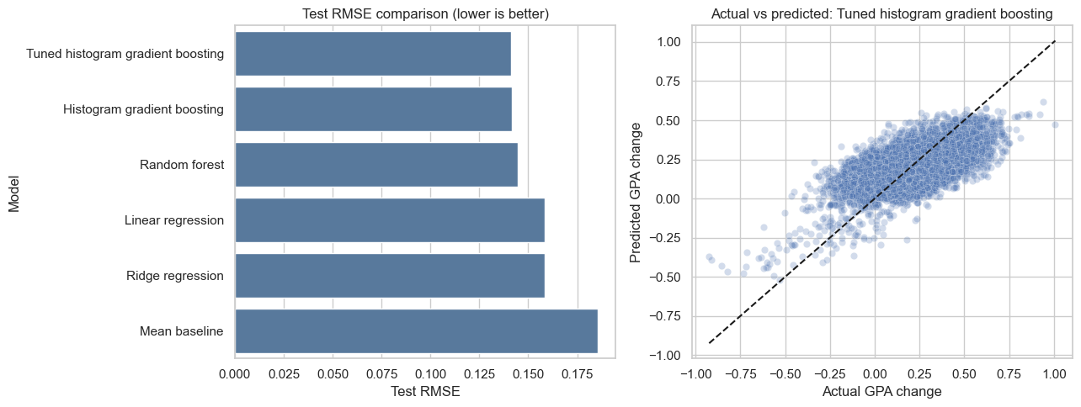
Figure 7. Reserved-test RMSE by model and actual versus predicted GPA change for the selected tuned HGB model. The dashed diagonal represents perfect predictions.

6.3 Residual behaviour
Figure 8 shows residuals defined as actual minus predicted GPA change. Their mean was 0.0019 and their standard deviation was 0.1414. The near-zero mean indicates little overall directional bias, but the scatter demonstrates substantial unexplained record-level variation. Predictions also compressed extreme outcomes towards the centre, a common limitation when a model is optimised for average error and extreme cases are sparse.
The median absolute error was 0.0922. Of the 10,000 test predictions, 53.57% were within 0.10 GPA points of the observed change and 84.34% were within 0.20. Remaining error and moderate R² prevent use as a high-confidence individual decision rule.
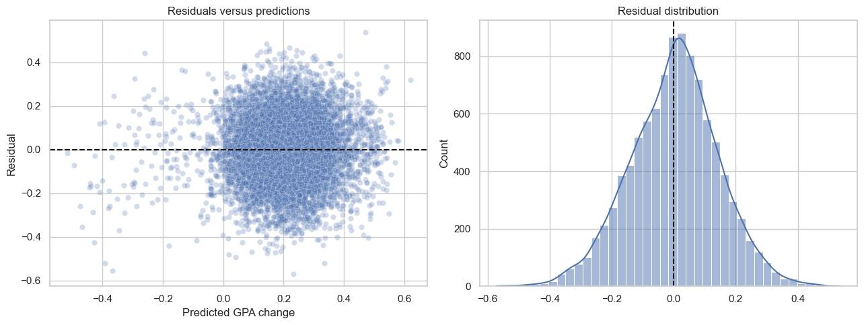
Figure 8. Residuals against predicted GPA change and the residual distribution for tuned HGB.

6.4 Direction-specific error and bias risk
The asymmetric target made the near-zero overall residual insufficient as a bias check. Of the test observations, 1,203 were decreases, 11 were unchanged and 8,786 were increases. For decreases, MAE was 0.1979, RMSE was 0.2208 and mean residual was -0.1916. Because residual equals actual minus predicted, this shows systematic overprediction: the model pulled GPA declines towards the much more common positive centre. Increase cases had MAE 0.0993, RMSE 0.1266 and mean residual 0.0286. The 11 unchanged cases were too few for a stable subgroup conclusion but had MAE 0.1615.
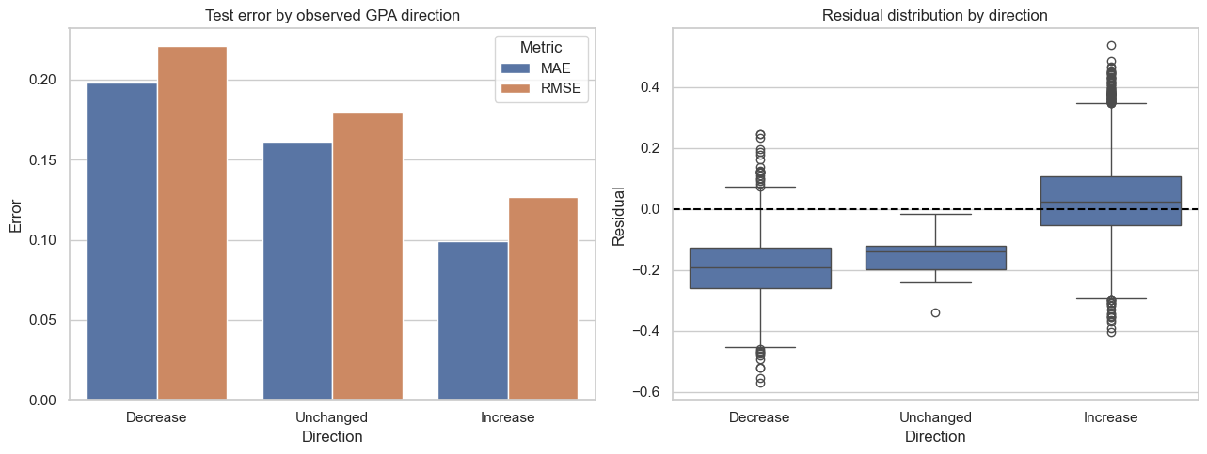
Figure 9. Test MAE, RMSE and residual distributions separated by observed GPA-change direction. The same tuned model and untouched test set are used for all groups.
These differences demonstrate predictive bias across outcome regions. Balancing by sign would redefine the continuous outcome, so aggregate and direction-specific results are reported instead. The model should not support individual interventions, especially for possible GPA declines.
A reproducibility check reran the established model workflow with the added EDA and subgroup diagnostics and reproduced all core metrics. Cleanup-only execution warnings did not affect the results.
The test partition also selected the diagnostic plot model. No refitting followed, but repeated confirmatory use may be optimistic relative to external evaluation.

7 Analysis and Recommendations

7.1 Answer to the research question
The clearest finding to emerge from the analysis is that AI-use variables added out-of-sample predictive information when combined with previous GPA and general study context. As Table 8 shows, the context-only HGB model achieved test R² = 0.2382, while AI variables alone achieved 0.1703. Combining the two groups raised test R² to 0.4170 and reduced RMSE from 0.1618 to 0.1415 relative to context alone. The R² increment was 0.1788. This is a change in predictive performance, not a percentage increase in GPA and not an estimate of an AI effect.
Table 8. HGB feature-set comparison
Feature set | CV MAE | CV RMSE | CV R² | Test MAE | Test RMSE | Test R²
Context only | 0.1254 | 0.1638 | 0.2378 | 0.1239 | 0.1618 | 0.2382
AI variables only | 0.1356 | 0.1708 | 0.1708 | 0.1347 | 0.1689 | 0.1703
Context and AI variables | 0.1129 | 0.1443 | 0.4084 | 0.1114 | 0.1415 | 0.4170

AI variables were therefore informative but insufficient by themselves. The strongest prediction required academic context and AI-related behaviour together. This result is consistent with the wider literature's emphasis on context and quality of use. AI literacy includes understanding, application, evaluation and ethics rather than exposure alone (Ng et al., 2021), while effective prompting also depends on domain knowledge and critical checking (Lee & Palmer, 2025). The result should not be interpreted as validating the dataset's self-described skill measure; it only shows that the recorded AI fields helped this model discriminate between outcomes.

7.2 Why nonlinear models performed better
HGB and Random Forest outperformed Linear and Ridge Regression under the same folds and preprocessing. The tuned HGB test RMSE was 0.1414, compared with 0.1448 for Random Forest and 0.1583 for both linear models. This suggests that one additive coefficient per encoded feature did not capture all useful structure. Two descriptive findings support that interpretation. First, mean GPA change rose through the high-medium AI-hours quartile and then fell in the highest quartile. Second, the maximum feasible increase narrows as previous GPA approaches 4.0. Tree ensembles can represent thresholds and interactions without imposing a single straight-line relationship.
This pattern aligns cautiously with educational-data-mining evidence in which tree-based and other nonlinear models have performed competitively (Yağcı, 2022). It does not show that HGB is universally preferable: Waheed et al. (2020), for example, reported a deep model as strongest for a different classification task using virtual-learning data. Model ranking is conditional on the outcome, features, sample and validation protocol.
The optimisation result is also instructive. Randomised search improved HGB cross-validated RMSE from 0.1443 to 0.1441 and test R² from 0.4166 to 0.4185 relative to the untuned HGB. The gain was genuine within the recorded run but small. Tuning therefore refined an already suitable model rather than transforming performance. This supports explicit optimisation while cautioning against presenting search as inherently valuable irrespective of its measured benefit.

7.3 Predictive importance and anomalies
Figure 10 shows that Traditional_Study_Hours had the largest permutation importance (0.0328 increase in RMSE-based loss when shuffled), followed by Primary_Use_Case (0.0267), Weekly_GenAI_Hours (0.0174), Year_of_Study (0.0136), Prompt_Engineering_Skill (0.0122) and Pre_Semester_GPA (0.0108). Institutional policy and paid subscription made small contributions, while tool diversity, perceived dependency, exam anxiety and major category were near zero in this fitted model.
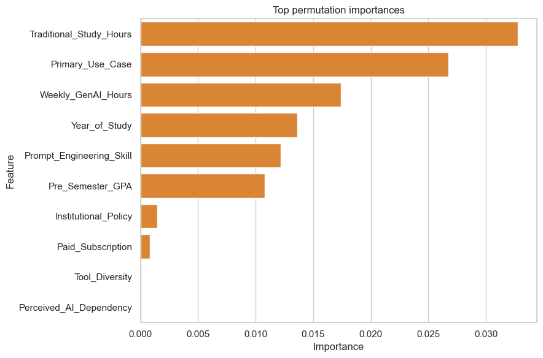
Figure 10. Test-set permutation importance for the selected tuned HGB model. Values show the mean deterioration in RMSE-based score after shuffling each source feature across five repetitions.
Traditional study hours ranking above any AI field is substantively important: AI behaviour did not replace conventional study context. At the same time, purpose of use ranking above weekly hours supports the argument that how a tool is used may be more informative than exposure quantity. The non-monotonic quartile pattern further rejects the simplistic recommendation that more hours should improve GPA.
These importance values do not isolate independent effects. Correlated features can substitute for one another when shuffled, and a variable may be useful because it proxies an unobserved factor. The near-zero importance of perceived dependency, for instance, does not establish that dependency is educationally irrelevant. It means only that shuffling this field did not materially worsen this model's test score after the other recorded predictors were available.

7.4 Relationship to prior evidence
Taken together, the results fit the literature's mixed rather than deterministic account of GenAI. Sun and Zhou (2024) found positive average effects in structured interventions, whereas Abbas et al. (2024) reported adverse associations in observational survey data. Molerov et al. (2026) found faster task completion and more examinations passed among users, but no better task accuracy or grades. The current model neither confirms nor refutes those effects because it uses different measures and has no intervention or credible control group. Its contribution is narrower: use-related fields improved prediction within the supplied records, and the form of the association was not simply monotonic.
The final R² of 0.4185 left most test variation unexplained. Missing course, assessment, instructor and socioeconomic context plus extreme-outcome compression require caution.
Direction-specific validation revealed the clearest practical bias risk. Test MAE for GPA decreases (0.1979) was nearly twice that for increases (0.0993), and the mean residual of -0.1916 shows that declines were systematically predicted as less severe. This behaviour is consistent with the 87.52% positive target share and central prediction compression. The result does not justify changing the observed distribution, but it prevents the near-zero overall mean residual from being presented as evidence of equal performance.

7.5 Recommendations
First, the tuned HGB should be retained as the assignment's predictive benchmark because it led both cross-validation and test evaluation. It should not be deployed as an intervention rule or used to label individual students as likely to benefit from AI. At most, its outputs could support hypothesis generation after independent validation. Any later deployment study must set direction-specific acceptance thresholds and examine errors across documented demographic and institutional groups that are absent from this file.
Second, future data collection should document the institution, sampling frame, time period, consent, collection instrument and real-versus-synthetic status. Verified behavioural logs should be distinguished from self-report. Course, assessment and instructor variables should be added because they offer plausible explanations for the unexplained variance.
Third, future analysis should predefine a genuine low-use or non-use comparison and follow students longitudinally if the objective changes from prediction to effect estimation. External validation on a separately collected cohort is more valuable than increasingly extensive tuning of the present file.
Finally, educational recommendations should emphasise purposeful and critical use rather than maximising AI hours. Teaching should combine prompt practice with subject knowledge, output verification and ethical judgement, consistent with AI-literacy research (Laupichler et al., 2022; Lee & Palmer, 2025). Whether such support improves GPA requires controlled evaluation; it cannot be inferred from the present feature importances.

8 Conclusion
The following conclusions can be drawn from this predictive study. AI-use variables improved held-out prediction of semester GPA change when they were combined with previous GPA and general study context. The combined HGB feature-set model achieved test R² = 0.4170, compared with 0.2382 for context only and 0.1703 for AI variables only. Among the candidate algorithms, Histogram Gradient Boosting produced the strongest cross-validated performance, and its tuned version achieved test MAE 0.1112, RMSE 0.1414 and R² = 0.4185. These values answer the research question within the supplied dataset; they do not show that AI use caused any student's GPA to change.
All six objectives were met. Every field was profiled for type, completeness, cardinality, range, distribution and category frequency without altering the raw data. The 50,000 rows, 16 source columns, absence of missing values, duplicates and invalid ranges were reported. GPA change was constructed as a continuous target, while context, AI-only and combined feature groups enabled a direct ablation. Identifier and post-outcome fields were removed, and preprocessing was fitted within model pipelines. A baseline and four regressors were compared using identical five-fold validation. The strongest nonlinear family was tuned using development folds, then confirmed on a reserved test set. Finally, residuals, prediction tolerances and permutation importance were interpreted alongside the literature.
What worked best was the controlled comparison: nonlinear ensembles improved on the linear models, and cross-validation and test rankings were consistent. The feature-set experiment also answered a substantive question rather than merely selecting an algorithm. What worked less well was extensive tuning; the HGB improvement was small, indicating that the initial settings were already adequate. The final model also left most outcome variation unexplained and compressed extreme predictions. Direction-specific testing exposed this limitation: MAE was 0.1979 for GPA decreases versus 0.0993 for increases, with declines systematically predicted towards the positive centre.
The main limitation is evidential rather than computational. Dataset collection, sampling, geography, ethics and real-versus-synthetic status are undocumented, and perfect cleanliness reduces confidence that the file reflects unprocessed field data. Future work should collect longitudinal, provenance-rich records; include course, assessment and instructor context; define a credible comparison group; and validate the model externally. A controlled design would be required before making intervention claims. The practical implication is therefore cautious: purposeful AI-use variables deserve inclusion in future student-success research, but neither usage hours nor feature importance should be converted into prescriptive advice without stronger evidence.

References
Arlot, S., & Celisse, A. (2010). A survey of cross-validation procedures for model selection. Statistics Surveys, 4, 40–79. https://doi.org/10.1214/09-SS054
Bergstra, J., & Bengio, Y. (2012). Random search for hyper-parameter optimization. Journal of Machine Learning Research, 13(10), 281–305. https://jmlr.org/papers/v13/bergstra12a.html
Breiman, L. (2001). Random forests. Machine Learning, 45, 5–32. https://doi.org/10.1023/A:1010933404324
Fisher, A., Rudin, C., & Dominici, F. (2019). All models are wrong, but many are useful: Learning a variable's importance by studying an entire class of prediction models simultaneously. Journal of Machine Learning Research, 20(177), 1–81. https://jmlr.org/papers/v20/18-760.html
Friedman, J. H. (2001). Greedy function approximation: A gradient boosting machine. The Annals of Statistics, 29(5), 1189–1232. https://doi.org/10.1214/aos/1013203451
Harris, C. R., Millman, K. J., van der Walt, S. J., et al. (2020). Array programming with NumPy. Nature, 585, 357–362. https://doi.org/10.1038/s41586-020-2649-2
Hoerl, A. E., & Kennard, R. W. (1970). Ridge regression: Biased estimation for nonorthogonal problems. Technometrics, 12(1), 55–67. https://doi.org/10.1080/00401706.1970.10488634
Hunter, J. D. (2007). Matplotlib: A 2D graphics environment. Computing in Science & Engineering, 9(3), 90–95. https://doi.org/10.1109/MCSE.2007.55
McKinney, W. (2010). Data structures for statistical computing in Python. In Proceedings of the 9th Python in Science Conference (pp. 56–61). https://doi.org/10.25080/Majora-92bf1922-00a
Waskom, M. L. (2021). seaborn: Statistical data visualization. Journal of Open Source Software, 6(60), 3021. https://doi.org/10.21105/joss.03021
Abbas, M., Jam, F. A., & Khan, T. I. (2024). Is it harmful or helpful? Examining the causes and consequences of generative AI usage among university students. International Journal of Educational Technology in Higher Education, 21(1), Article 10. https://doi.org/10.1186/s41239-024-00444-7
Alyahyan, E., & Düştegör, D. (2020). Predicting academic success in higher education: Literature review and best practices. International Journal of Educational Technology in Higher Education, 17(1), Article 3. https://doi.org/10.1186/s41239-020-0177-7
Crompton, H., & Burke, D. (2023). Artificial intelligence in higher education: The state of the field. International Journal of Educational Technology in Higher Education, 20(1), Article 22. https://doi.org/10.1186/s41239-023-00392-8
Hellas, A., Ihantola, P., Petersen, A., Ajanovski, V. V., Gutica, M., Hynninen, T., Knutas, A., Leinonen, J., Messom, C., & Liao, S. N. (2018). Predicting academic performance: A systematic literature review. In Proceedings companion of the 23rd annual ACM conference on innovation and technology in computer science education (pp. 175–199). ACM. https://doi.org/10.1145/3293881.3295783
Kasneci, E., Sessler, K., Küchemann, S., Bannert, M., Dementieva, D., Fischer, F., Gasser, U., Groh, G., Günnemann, S., Hüllermeier, E., Krusche, S., Kutyniok, G., Michaeli, T., Nerdel, C., Pfeffer, J., Poquet, O., Sailer, M., Schmidt, A., Seidel, T., . . . Kasneci, G. (2023). ChatGPT for good? On opportunities and challenges of large language models for education. Learning and Individual Differences, 103, 102274. https://doi.org/10.1016/j.lindif.2023.102274
Laupichler, M. C., Aster, A., Schirch, J., & Raupach, T. (2022). Artificial intelligence literacy in higher and adult education: A scoping literature review. Computers and Education: Artificial Intelligence, 3, 100101. https://doi.org/10.1016/j.caeai.2022.100101
Lee, D., & Palmer, E. (2025). Prompt engineering in higher education: A systematic review to help inform curricula. International Journal of Educational Technology in Higher Education, 22(1), Article 7. https://doi.org/10.1186/s41239-025-00503-7
Lo, C. K. (2023). What is the impact of ChatGPT on education? A rapid review of the literature. Education Sciences, 13(4), 410. https://doi.org/10.3390/educsci13040410
Molerov, D., Federiakin, D., Zlatkin-Troitschanskaia, O., Shenavai, K., Trierweiler, L., & Nagel, M.-T. (2026). The relationship between AI-chatbots use, student assessment performance and learning outcomes in higher education. Unterrichtswissenschaft. Advance online publication. https://doi.org/10.1007/s42010-026-00242-2
Nagi sisiro. (2026). Impact of Ai on Students [Data set]. Kaggle. https://www.kaggle.com/datasets/laveshjadon/ai-impact-on-students
Ng, D. T. K., Leung, J. K. L., Chu, S. K. W., & Qiao, M. S. (2021). Conceptualizing AI literacy: An exploratory review. Computers and Education: Artificial Intelligence, 2, 100041. https://doi.org/10.1016/j.caeai.2021.100041
Pedregosa, F., Varoquaux, G., Gramfort, A., Michel, V., Thirion, B., Grisel, O., Blondel, M., Prettenhofer, P., Weiss, R., Dubourg, V., Vanderplas, J., Passos, A., Cournapeau, D., Brucher, M., Perrot, M., & Duchesnay, É. (2011). Scikit-learn: Machine learning in Python. Journal of Machine Learning Research, 12, 2825–2830. https://jmlr.org/papers/v12/pedregosa11a.html
Probst, P., Wright, M. N., & Boulesteix, A.-L. (2019). Hyperparameters and tuning strategies for random forest. WIREs Data Mining and Knowledge Discovery, 9(3), e1301. https://doi.org/10.1002/widm.1301
Sun, L., & Zhou, L. (2024). Does generative artificial intelligence improve the academic achievement of college students? A meta-analysis. Journal of Educational Computing Research, 62(7), 1676–1713. https://doi.org/10.1177/07356331241277937
Waheed, H., Hassan, S.-U., Aljohani, N. R., Hardman, J., Alelyani, S., & Nawaz, R. (2020). Predicting academic performance of students from VLE big data using deep learning models. Computers in Human Behavior, 104, 106189. https://doi.org/10.1016/j.chb.2019.106189
Yağcı, M. (2022). Educational data mining: Prediction of students' academic performance using machine learning algorithms. Smart Learning Environments, 9(1), Article 11. https://doi.org/10.1186/s40561-022-00192-z
Zawacki-Richter, O., Marín, V. I., Bond, M., & Gouverneur, F. (2019). Systematic review of research on artificial intelligence applications in higher education: Where are the educators? International Journal of Educational Technology in Higher Education, 16(1), Article 39. https://doi.org/10.1186/s41239-019-0171-0

Acknowledgements
The author acknowledges Nagi sisiro for making the Impact of Ai on Students dataset available through Kaggle, the CT046-3-M-AML teaching team for the learning materials and assignment guidance, and the open-source contributors to Python, pandas, NumPy, scikit-learn, Matplotlib, seaborn and Jupyter.
OpenAI Codex was used for research-workflow support, code and report review, language editing and Microsoft Word document assembly. The author verified the cited sources, executed model outputs, numerical results, analysis and final wording and remains responsible for the submitted work.

